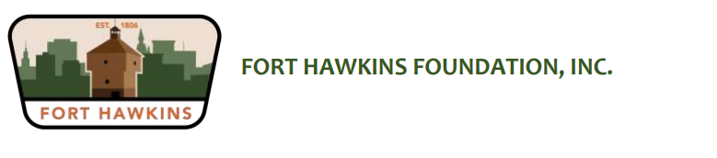

|  |  |
| --- | --- |
| **Board of Directors**  **Ashley Quinn, Chair**  **Matt Jennings, Vice Chair**  **Sandra Darby, Secretary**  **Lynn Stokes, Treasurer**  **Cathy Brignole**  **John Goolsby**  **Micheal Jamison, Jr.**  **Michael Lynch**  **Johnny Mack Nickles**  **Becki Sandifer**  **478-257-7798**  [forthawkinsfoundation@gmail.com](mailto:forthawkinsfoundation@gmail.com)  [info@forthawkins.com](mailto:info@forthawkins.com)  forthawkins.com    P O Box 7344  Macon, GA 31209  736 Emery Highway  Macon, GA 31217 | July 28, 2023  Fort Hawkins Volunteer Program  Fort Hawkins Foundation, Inc.  PO Box 7344  Macon, GA 31209  Dear Community Supporter,  Fort Hawkins needs your help and here is your chance to make a difference!  The Fort Hawkins Foundation, Inc. is excited to launch a new Volunteer Program. We are asking individuals and organizations, who support our mission and appreciate the unique history of our city’s origin, to join us on the Fort Hawkins team.  As a volunteer, you will bring the work of the Fort Hawkins Foundation, Inc. to life by sharing your talents and expertise. I am counting on you to help bring our appreciation of historic preservation to the fort and, most of all, to our community.  Attached is our Hawkins Heroes Volunteer application. If you would like to join our team, please complete application and mail via USPS or email to [info@forthawkins.com](mailto:info@forthawkins.com).  Fort Hawkins Foundation, Inc.  PO Box 7344  Macon, GA 312019  Yours in patriotism,    Fort Hawkins Foundation, Inc. |
|  |  |